**OPTIMIZE WINDOWS 10 MEMORY:-**

**1.**

The Command Prompt Commands –

**Dism /Online /Cleanup-Image /CheckHealth**

**Dism /Online /Cleanup-Image /ScanHealth**

**Dism /Online /Cleanup-Image /RestoreHealth**

**sfc /SCANNOW**

Hi guys. In this video, we will you guys how to tell you guys how to fix the problem that you have high RAM or Memory Usage on your PC. Sometimes, your memory may reach a peak of 99 percent or 98 percent or any high ninety-ish figure. This video is a long one because we covered all the important parts and all the available software solutions for this RAM/Memory problem. This should work on all windows: XP, Vista, 7, 8, 8.1, and obviously Windows 10. These are the quickest and simplest ways to solve this problem.

2. **Windows 10 Optimize Memory from registry (Value 2->4)**

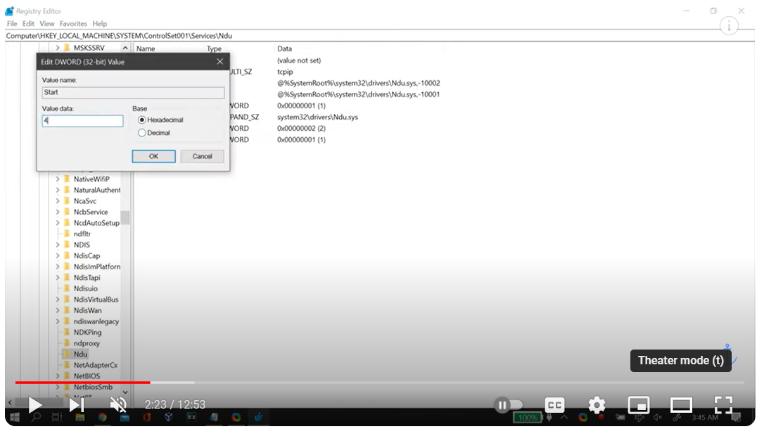

3. value **(0->1)**

